
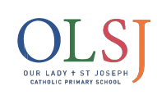

HANDWRITING POLICY
OUR LADY & ST JOSEPH CATHOLIC PRIMARY SCHOOL

PREPARED BY: Amy Charles
APPROVED BY: Governing Body
DATE: November 2022
REVIEW DATE: February 2024
DPO CHECKED: February 2022

Handwriting Policy

At Our Lady and St Joseph Catholic Primary School, we are very proud of our pupil’s handwriting and take particular care in our handwriting style. We use Letter-join’s on-line handwriting resource and Lesson Planners as the basis of our handwriting policy as it covers all the requirements of the National Curriculum. The school's agreed handwriting style develops from print, in Early Years and Foundation Stage and Year One, then moves to cursive from Years Two to Six. This ensures there is progression in handwriting style from Early Years Foundation Stage through to the end of Key Stage 2.

Objective
Handwriting is a basic skill that influences the quality of work throughout the curriculum. By the end of Key Stage 2 all pupils should have the ability to produce fluent, legible and, eventually, speedy joined-up handwriting, and to understand the different forms of handwriting used for different purposes. Our intention is to make handwriting an automatic process that does not interfere with creative and mental thinking.

Aims

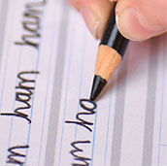
- To develop a neat, legible, speedy handwriting style using continuous cursive letters, which leads to producing letters and words automatically in independent writing.
- To establish and maintain high expectations for the presentation of written work.
- For pupils to understand, by the end of Year 6, the importance of neat presentation and the need for different letterforms (cursive, printed or capital letters) to help communicate meaning clearly.

Consistency throughout the School
Pupils should experience coherence and continuity in the learning and teaching of handwriting across all school years and be encouraged to take pride in the presentation of their work. Our objective is to help pupils enjoy learning and developing their handwriting with a sense of achievement and pride.

Expectations
All teaching staff are encouraged to model the printed or cursive style of handwriting chosen for each year group in our school in all their handwriting, whether on whiteboards, displays or in pupils’ books.

Inclusion
For children who experience handwriting difficulties due to fine motor development, including those who are left-handed and those with special educational needs, the appropriate additional support will be put into place. Letter-join’s Lesson Planners all include differentiation activities for extra practice and challenge.

The Organisation of Handwriting
Handwriting Frequency
Handwriting is a cross-curricular task and will be taken into consideration during all lessons. Formal teaching of handwriting will be carried out regularly and systematically to ensure Key Stage targets are met.
Planning and Delivery
Cursive handwriting is taught and modelled in marking and teaching from Reception and throughout Key Stage 1 and Key Stage 2. All teachers give specific attention to pencil and pen control, grip and posture in helping pupils to develop a legible cursive style. Teachers identify all left-handed pupils in their class. Left-handers should always sit on the right of a right-handed child to avoid collision. In Reception and Year 1, children are encouraged to write using a wide variety of media, from chalks and charcoal to crayons. Children will start handwriting using a soft pencil. When fine motor skills have been established a handwriting pen can be used. From Year Three, children with excellent handwriting are awarded pen licenses which can be used in all subjects except maths.

Progression

Early Years and Foundation Stage
Early Years and Foundation Stage teach handwriting through the print method. Children in the Early Years Foundation Stage are involved in a variety of activities to develop their physical development. For our youngest pupils we teach short handwriting sessions, which will include the following:
- enhancing gross motor skills such as air-writing, pattern-making and physical activities
- exercises to develop fine motor skills such as mark-making on paper, whiteboards, sensory trays, iPads, tablets, etc.
- becoming familiar with letter shapes, their sounds, formation and vocabulary
- correct sitting position and pencil grip for handwriting

Handwriting is divided into three sections covering:
- Pre-writing patterns
- Easy letters and words
- Harder letters and words

By the end of the Early Years and Foundation Stage, children should be able to recognise and form all the printed, lowercase letters of the alphabet.
Opportunities for mark making are planned in both the inside and outside environment. Children are offered a range of materials and experiences for mark making developed across all six areas of learning. When teachers are modelling activities, they demonstrate and encourage correct pencil grip.

Key Stage One – Years One and Two

In Key Stage One, children continue to use the print method. Teaching progresses to longer lessons per week:
- continuing with gross and fine motor skills exercises
- strengthening handwriting, learning and practice
- numerals, capitals and printed letters; where and when to use, learning and practice
- Key Stage One SATs Grammar, Punctuation and Spelling exercises

Year One
In Year One, children are taught how to correctly write capital letters, uses of printed letters, numbers, punctuation, maths symbols and other symbols. Pre-cursive patterns and cursive letters are then introduced in preparation for Year Two when children are required to start joining their handwriting.

Coverage is divided into three sections covering:
• warm-ups, letter families and capital letters
• uses of printed letters
• numbers and symbols
• introducing pre-cursive patterns and cursive letters
When leaving Year One, children should be confident in writing all the capital and printed letters, numbers and symbols and start to become familiar with the orientation of cursive letters.
Year Two
In Year Two, children are introduced to cursive letters and how to join them. They will have regular practice in letter formation and joining their handwriting.
The sections cover:
- Cursive letters and words
- Letter families
- High frequency words
- Joining techniques
- Sequencing sentences
- Dictation exercises
- Times table facts
Grammar, Punctuation and Spelling practice for Key Stage One SATS
With regular handwriting practice throughout Year 2, children develop the fluency and speed of their letter formation and orientation and will have had plenty of opportunities to practise neat handwriting.

Lower Key Stage Two – Years Three and Four

Handwriting lessons will continue twice a week in Lower Key Stage Two. In Lower Key Stage Two children use the cursive script, building on the foundations from the Early Years and Foundation Stage and Key Stage One. Children should be using a cursive style throughout their independent writing in all subjects, helping to refine their handwriting in line with the requirements of each lesson.
Year Three
In Year Three children will continue to develop legibility, consistency and the quality of their cursive handwriting. Teaching covers topics such as dictation, double letters, number vocabulary, palindromes, tongue twisters, MFL (French and Spanish), onomatopoeia, simile and statutory spellings.
By the end of Year Three, children should have improved their fluency of their joined handwriting and use a variety of resources which link handwriting to other areas of the curriculum.
Year Four
In Year Four, teaching focuses on using handwriting practice to support other subjects in the curriculum and, at the same time, builds on fluency and consistency. Handwriting lessons promote meaningful links with other subjects such as English, maths, science, geography, French and Spanish. Making such links enables children to apply the skills they are learning in context and also provides depth to the curriculum. Learners will continue to build on producing fluent, consistent and legible handwriting through the regular practice offered in this handwriting lessons. By the end of Year Four, children will have practised applying size-appropriate handwriting to all areas of the curriculum whilst maintaining fluency and legibility.

Upper Key Stage Two – Years Five and Six
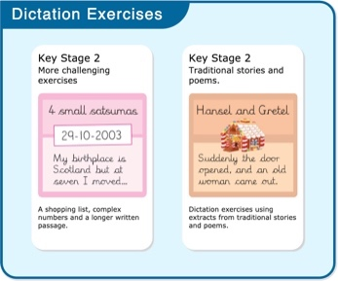
More advanced handwriting techniques will be taught during lessons:
- reinforcing cursive handwriting across the curriculum
- form-filling/labelling using printed and capital letters
- dictation exercises promoting quick note-taking and speedy handwriting writing skills
- KS2 SATs SPaG practice

Handwriting at Home
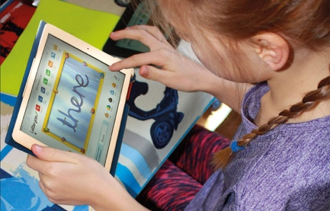
Pupils are encouraged to practise their handwriting at home by using the Pupil log-in for Letter-join. Teachers can set Home Learning Tasks which may include:
- Magic Patterns
- Magic Words
- SoundMatch
- PhonicsMatch
- LetterMatch
- LetterLotto
- Letter Families activity
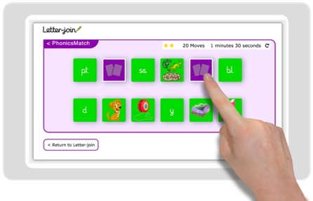
- Word Search
- Word Bank
- Spelling lists
- Write it Right!
Children can also watch the word and letter animations and practice and explore other handwriting resources on Letter-join.

