Monday Time taken  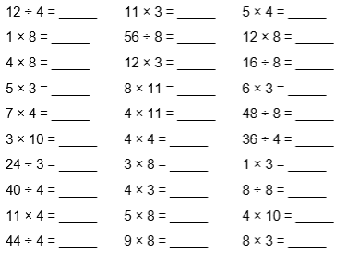 | Tuesday Time taken  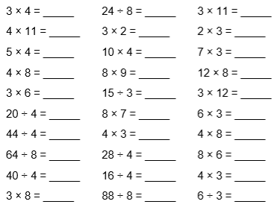
Wednesday Time taken  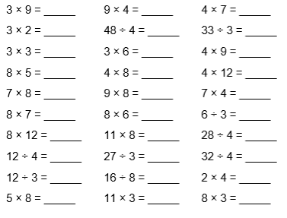 | Thursday Time taken  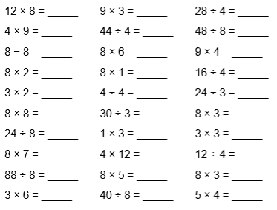
Friday Time taken  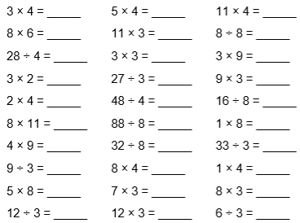 | Saturday Time taken  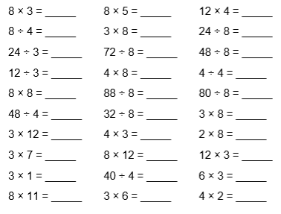

Family Big Question:

Why do people do good things?

Reading Review:

My book is:____________________________________________ by ____________________________________
___________________________________________________________________________________________________________________________________________________________________________________________________________________________________________________________________________________________________________________________________________________________________________________________________________________________________________________________________________________________________________________________________________________________________________________________________________________________________________________________________________________________________________________________________________________________________________________________________________________________________________________________________________________________________________________________________________________________________________________________________________________________________________________________________________________________________________________________________________________________
In your reading review you could write about your favourite part, your least favourite part, certain words the author uses and why, what characters are like and how the author makes you feel towards them, a summary of what happened or what you think may happen next and why. Remember to refer to and quote the text.

Spellings: Spelling Test will happen every week  Your child’s spelling score last week was:  accidentally  address  answer  appear  arrive  believe  bicycle  breath  breathe | Handwriting:  Please practice this in your handwriting home book, practice it on its own, within words, or in sentences. One page per week minimum.  This week’s letter is:  