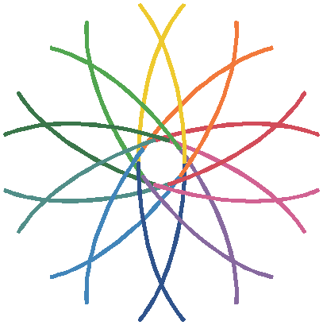
Reception Newsletter

Friday 13th May 2022

This week in Reception…

Literacy: Our book of the week was “Mrs. Wishy-Washy.” The children have been talking about different kinds of farm animals and our last trip to the local farm.
Maths: We have been learning about symmetry. We have also been looking at symmetric and asymmetric patterns and making our own symmetrical pictures.

ar | or | ur

Please support your child to read the words below by applying our strategy of; look at the letter, make the sound and blend it altogether.

park | fork | hurt | short | surf
horn | star | curl | scar | torch

Please apply the same strategy as above to read the words (the underlined words) but read the Sight Words by sight.

I went to the park.
I have a big scar.
I use my torch to see in the dark.
My curl is short.

45 Sight Words
We have sent home a pencil case with all 45 Sight Words on flash cards. Please support your child by reading the words to them and asking them to repeat after you. Our 45 High Frequency words this week are ...

a | she | at

Phase 3 Sight Words
We are now learning our phase 3 Sight Words. Below are our words of the week. We have been matching these words in our book of the week. Please note there will be some overlaps with the 45 Sight Words. A list of the phase 3 Sight Words have been stuck into the “Reading Explorers” book and we are sending a copy home this week.

be | look

Have a lovely weekend
The Reception Team.

