Write a list of things you can see or answer the questions below in full sentences. EG: The pig is eating white chocolate ice cream.
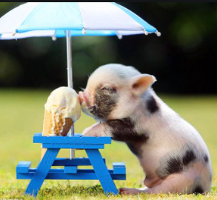
What flavour is the ice-cream?
How does the pig feel?
What will the pig say to you?
What would you do if you saw this pig?

Maths Homework
Please practise telling O’clock and half past time using the clocks the children have made in school this week.

