Name:_________________________

NUMBER

Addition
When writing down sums, separate the numbers into units, tens, hundreds and thousands. List the numbers in a column and always start adding with the units first.
So when adding together 7948 + 1223, you should write it down like this:
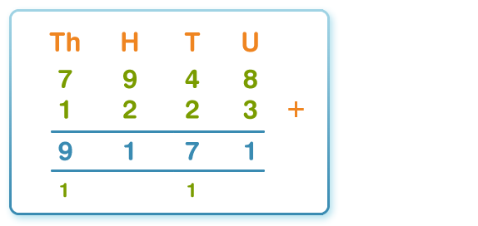
Some tips for addition
- Estimate first and check afterwards - it's a good idea to estimate a rough answer first and then check your actual answer.
- Order doesn't matter - remember that in addition 394 + 88 is the same as 88 + 394.
Key words - look out for these words in problems: total, sum, altogether, more. They all indicate an addition calculation

Subtraction
Writing it down
If the numbers are too high or too difficult to subtract in your head, write them down in columns. Always start subtracting with the units first.
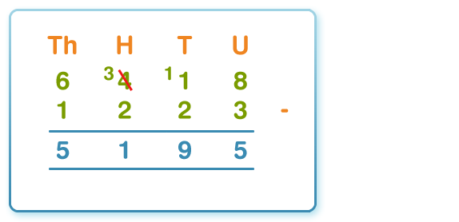
Spot the key words Look out for these words in problems: take away, difference, less than, minus, decrease, fewer than, reduce. They all indicate a subtraction calculation.

Ordering decimals
Ordering decimals means putting them in order from smallest to largest or from largest to smallest. Write down the numbers in a column and make sure the decimal points line up. Compare the digits in each column, starting on the left. Write down place value headings if it helps you.
Compare 0.459 and 0.495 to see which is bigger:
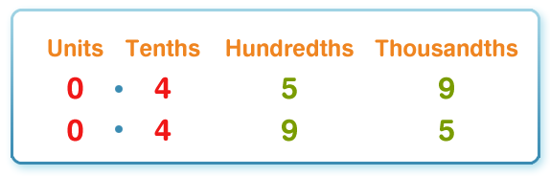
- Both numbers have 0 units. So look in the tenths column.
- Both numbers have 4 tenths. So look in the hundredths column.
- 0.495 has 9 in the hundredths column whereas 0.459 only has 5 in the hundredths column. (There is no need in this example to compare the thousandths column.)
So 0.495 is bigger than 0.459.

Adding and subtracting decimals
Line up the decimal points and then add or subtract as normal as if the decimal point wasn't there. Don't forget to put the decimal point in your answer.
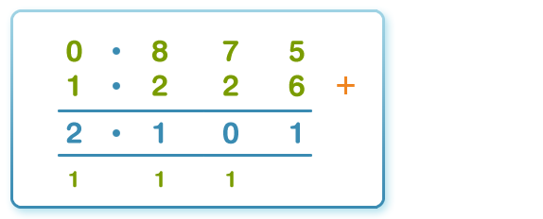

Converting to and from decimals
To change a decimal to a percentage, multiply it by 100. 0.35 x 100 = 35%
- To change a fraction to a decimal, divide the top number (the numerator) by the bottom number (denominator). 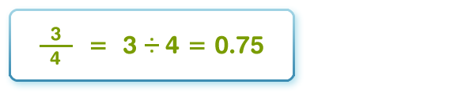
- A decimal fraction with one decimal place is written as tenths.
- A decimal fraction with two decimal places is written as hundredths. 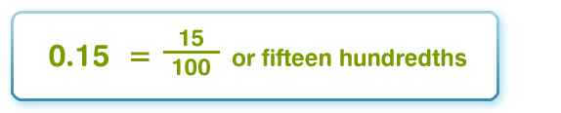
A decimal fraction with three decimal places is written as thousandths 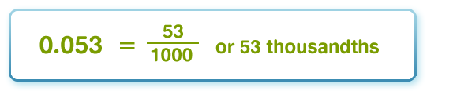

Factors
Factors are numbers that divide exactly into another number.
The factors of 12, for example, are 1, 2, 3, 4, 6 and 12.
Factors can be shown in pairs. The factors of 12 can be shown:
- 1 and 12 1 x 12 = 12
- 2 and 6 2 x 6 = 12
- 3 and 4 3 x 4 = 12
Each pair multiplies to make 12.
Multiples
Multiples are really just extended times tables.
- The multiples of 2 are all the numbers in the 2 times table: 2, 4, 6, 8, 10 and so on. Multiples of 2 always end with a 2, 4, 6, 8 or 0. You can tell 2286, for example, is a multiple of 2 because it ends with a 6.
- The multiples of 5 are all the numbers in the 5 times table: 5, 10, 15, 20, 25 and so on. Multiples of 5 always end with a 5 or a 0. You can tell 465, for example, is a multiple of 5 because it ends with a 5.
- The multiples of 10 are all the numbers in the 10 times table: 10, 20, 30, 40, 50 and so on. Multiples of 10 always end with a 0. You can tell 3780, for example, is a multiple of 10 because it ends with a 0.
What is a fraction?
A fraction is a part of a whole. There are two numbers to every fraction:
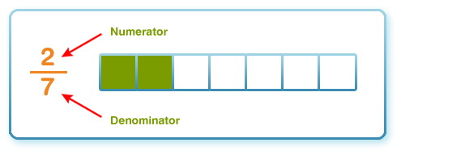
- The top number of the fraction is called the numerator. The bottom number is called the denominator.
Improper and mixed fractions
An improper fraction has a numerator that is bigger than its denominator, for example ¹⁰/₇
⁹/₄ is an improper fraction. It means nine quarters. If you think of this as cakes, nine quarters are more than two whole cakes. It is 2 ¹/₄ cakes.
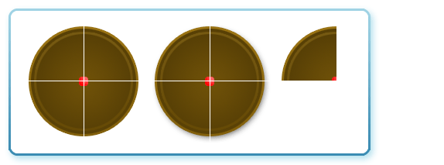
- 2 ¹/₄ is a mixed fraction because it has a whole number and a fraction together.
Fractions of quantities
To find a fraction of a quantity:
- Divide the quantity by the denominator
- Multiply the answer you get by the numerator
To find ²/ ₅ of £15, for example:
- Divide 15 by 5 (the denominator): 15 ÷ 5 = 3
- Multiply the answer 3 by 2 (the numerator): 3 x 2 = 6
- So ²/ ₅ of £15 is £6
Equivalent fractions
Equivalent fractions are fractions that look different but show exactly the same amount.
- 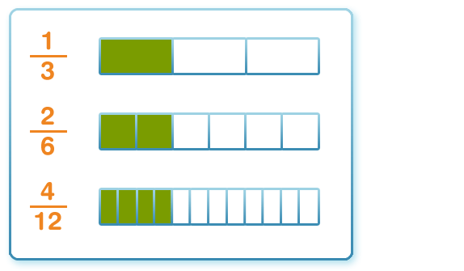
- You can make equivalent fractions by multiplying or dividing the numerator and denominator by the same number. 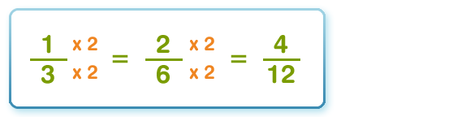
- You can simplify fractions by dividing the numerator and denominator by the same number. This is called cancelling. Sometimes fractions will cancel more than once. 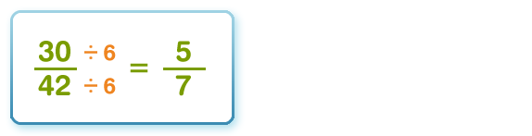

Ordering and comparing fractions
To compare fractions, you must first change them so they have the same denominator.
Compare ²/₃ and ³/₅ and find out which fraction is bigger.
- First look at the denominators (the bottom numbers).
- Find a new number that both denominators go into:
  - Try 9 - you can divide 9 by 3 but you can't divide 9 by 5.
  - Try 10 - you can divide 10 by 5 but not by 3, so that isn't right either.
  - Try 15 - you can divide 15 by 5 (which equals 3) and you can also divide 15 by 3 (which equals 5), so 15 is the new denominator.
- Now you have found a new denominator that is divisable by both numbers, you need to change the numerators (the top numbers).
- To change the numerators, simply multiply them by the number of times the denominator goes into 15.
  - So for ²/₃ - 3 goes into 15 five times, so you must multiply the numerator (2) by 5 which equals 10.
  - And for ³/₅ - 5 goes into 15 three times, so you must multiply the numerator (3) by 3 which equals 9.
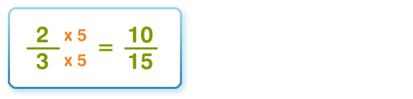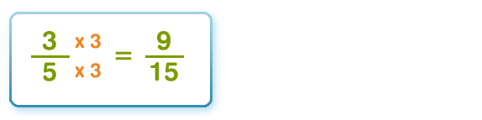
So now both fractions have been changed you can compare them to see which fraction is the biggest. ¹⁰/₁₅ is bigger than ⁹/₁₅ so the biggest original fraction is ²/₃.

Converting fractions to decimals
You can use a calculator to turn a fraction into a decimal.
Just divide the numerator by the denominator.
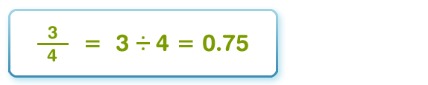

Money
Decimal points
When we write down pounds we use a £ sign, but if the amount is less than £1, we use the letter 'p' at the end of the amount. The p stands for pence: eg 73p.
Sometimes we need to convert pence amounts into pound amounts to make calculations. For amounts less than £1, we add a '£0' and a decimal point infront of the number. So, 73p becomes £0.73.
Every time we reach 100 pence, we convert it into £1. This is also written as £1.00.
The decimal point separates the whole pounds from the pence, for example: £1.42.
In this figure, there are one hundred and forty-two pence. We know one hundred pence is the same as £1.00. So, there is one whole pound, separated from the forty-two pence by the decimal point

Money problems
Useful tips for solving money problems:
- Read the words of the problem carefully to decide whether to use addition, subtraction, multiplication or division.
- If some of the prices in the problem are in pence and some are in pounds, change some of them so they are either all in pounds or all in pence.
Treat money problems just like normal number calculations, but remember to put the decimal point and pound symbol in the right place.

Multiplication
x
Multiplication is similar to addition because you make numbers bigger when you use multiplication. You could use addition to help you solve multiplication problems but it would take you a lot longer to work out your solution.
There are many words that mean the same thing as multiplication and you need to look out for them. They include:
- double
- groups of
- multiple of
- product
- times
- twice as much
For example, all the words in bold tell us that we need to use multiplication in our calculations:
What is the product of 8 and 12?
Danny has £3.12 in his pocket. Fiona has twice as much in her pocket. How much money does Fiona have?
Is 12 a multiple of 92?
Signs for multiplication
Some multiplication sums use signs to tell us what to do such as:
8 x 5
or
242 x 3 ____
When you use multiplication in your calculations you will always make the number you started with bigger.

Division
÷
Division is similar to subtraction because you make numbers smaller when you use division. You could use subtraction to help you solve division problems but it would take you a lot longer to work out your solution.
There are many words that mean the same thing as division or are linked with it and you need to look out for them. They include:
- divisible by
- factor
- halve
- left over
- remainder
- share
For example, all the words in bold tell us that we need to use division in our calculations:
Martine has 25 apples. If she shares them with her six friends, how many will be left over?
What are the factors of 96?
Is 75 divisible exactly by 6?
Signs for division
Some division sums use signs to tell us what to do such as:
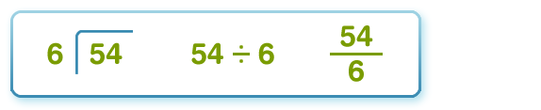
When you use division in your calculations you will always make the number you started with smaller. Numbers can't always be divided exactly and occasionally there are remainders or numbers left over.

Percentages
Per cent means 'out of 100'
Print
The sign % stands for 'per cent' which means 'out of 100'.
So:
- 40% means 40 out of 100
11% means 11 out of 100

Converting between percentages and fractions
Write the percentage as a fraction over 100 and then simplify:
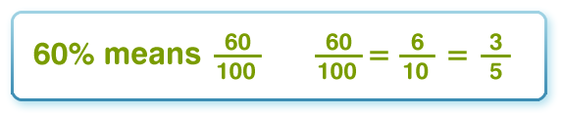
Learn these equivalent fractions and percentages:
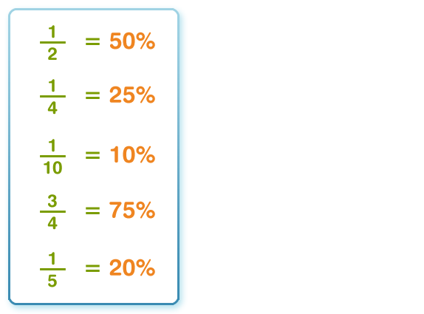
Percentage of a number
To find 20% of 30, convert the 20% to a decimal and then multiply by 30. 20% = 0.2 0.2 x 30 = 6 This is the best method as it always works.
Another way to find 20% of 30 is to first find 10% of 30 and then multiply by 2. 10% of 30 is 30 ÷ 10 = 3 2 x 3 = 6
Or a third way would be to recognise that 20% is equivalent to one fifth, and so just divide 30 by 5. 30 ÷ 5 = 6

