How are fingerprints used to identify someone?

Crime scene investigation is a science known as forensics. For every crime there is a series of evidence left behind that can lead authorities to the facts behind the incident. Skilled professionals analyse every bit of the area until they know all the details of a crime including, sometimes, who did it. Fingerprinting is a way of identifying who was at a location.

Fingerprints are the small ridges on the tips of our fingers and are different on every person. When a person touches a table or other surface, they leave behind a tell-tale sign of their fingerprints. Forensic investigators can then remove this fingerprint using a special powder and some tape. Then they can compare this evidence with a fingerprint that has been collected from the person to whom they are planning to compare. Fingerprint specialists evaluate the small curves and whorls of the fingerprints to determine if they are the same. There are a series of fingerprint patterns which are similar in all people.

Initially, a latent fingerprint is taken. A suspects right thumb is placed on a sheet a of glass or plastic film. The special powder, or in some instances talcum powder, is shaken over the sweaty thumbprint, and the excess is blown off. The investigator has to make sure that the powder is not blown into their eyes! A piece of sticky tape is then smoothed over the thumbprint, then peeled off carefully. After this, the tape is then stuck onto a piece of black card. Because the fingerprint has been collected, it can be taken to a lab to be analysed!

Next, a fingerprint record chart and ink pad can be used by the police to compare the collected print. A suspects index finger is rolled lightly on an ink pad, then rolled onto the correct space of a chart. Until all fingerprints from the right hand are collected, this process is repeated.

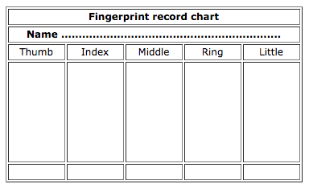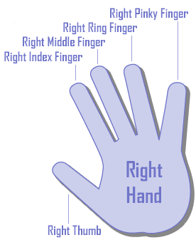

Each fingerprint is then analysed closely, and patterns are identified by looking at the types of fingerprint that are similar to all people:

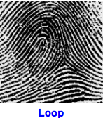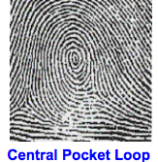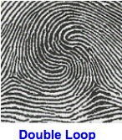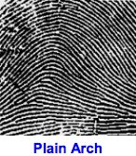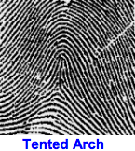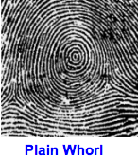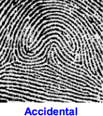
This information is collected on a chart for evidence. Finally, the person to whom the fingerprints belong is identified by looking carefully at the collected print and comparing it to the fingerprints that the authorities have on file.

Key

Forensics: Latin word for public – often related to law (the police)

Evidence: Things left at a crime scene on purpose or accidentally.

Authorities: Police or other law officials.

Professionals: A person trained to work in a particular career.

Latent fingerprint: Impressions made by the ridged skin of hands and feet on an object.

