Year 5 Homework

DUE IN Tuesday 3rd March

English:

Reading:

Read every day for at least 10 minutes. Please remember your child must have their book signed.

Writing:

**Imagine you are on a train or a bus and someone in the seat in front of you is talking on a mobile phone.**

**2. Listening to their side of the conversation you believe that they are involved in a thrilling adventure!**

**3. In your book write the side of the conversation you heard. Add interesting bits that make you wonder what the other person on the conversation is saying.**

Maths: Please do your class’s questions, but feel free to do the other questions too.

Mrs Edwards:

Using grid method answer these questions in your book. Draw the gird into your book.

42x6= 83x9= 76x2= 53x2= 72x9=

45x8 432x6 65x12= 53x8=

Mr. Everden:

Using any method you like estimating and answering these:

422x346= 81233x39= 736x32= 4553x24= 7342x94=

453x18 4332x63 652x12= 534x68=

543÷7= 7626÷6= 6723÷9= 6523÷8=

Topic: Look at these pictures of London dock areas. How is it different from modern day? Can you still see any of these things? If you took modern day pictures how would it be different

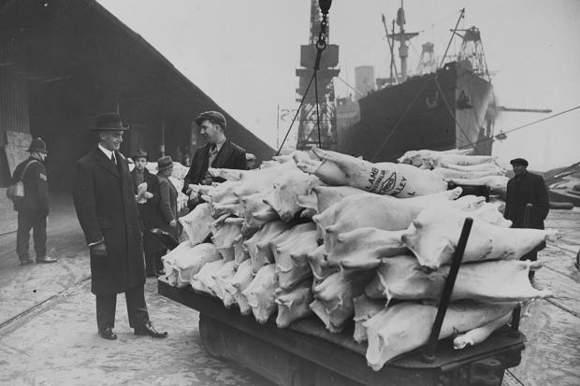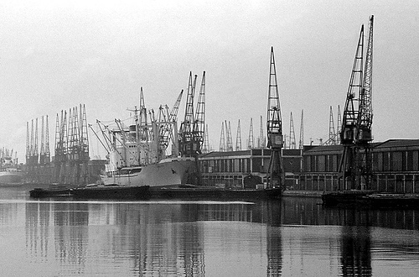

Spellings:

-ent ending

government development different management department president patient movement agreement environment treatment parent statement investment