Year 3 Homework
Thursday 14th June 2018
Please return it on Tuesday.
Maths- these questions are similar to the ones done in class today. Please complete one challenge.
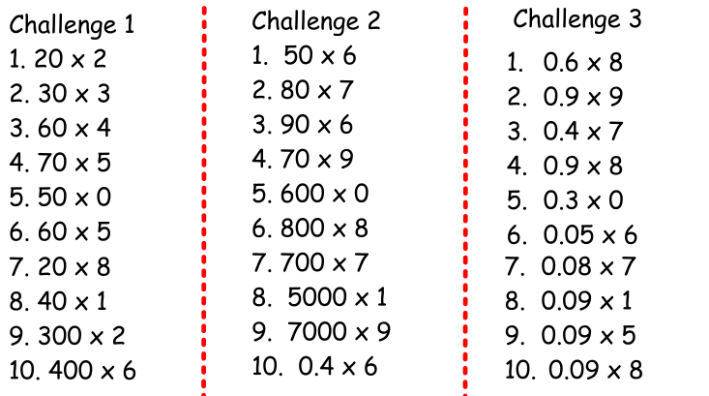
RE:
Imagine you were Simon when Jesus ‘called’ them to be disciples. If he wrote a diary what would he include? Write Simon’s diary for the day.

Mark 1:16-20 - Jesus Calls His First Disciples
¹⁶ As Jesus walked beside the Sea of Galilee, he saw Simon and his brother Andrew casting a net into the lake, for they were fishermen. ¹⁷ “Come, follow me,”Jesus said, “and I will send you out to fish for people.” ¹⁸ At once they left their nets and followed him.
¹⁹ When he had gone a little farther, he saw James son of Zebedee and his brother John in a boat, preparing their nets. ²⁰ Without delay he called them, and they left their father Zebedee in the boat with the hired men and followed him.

Spellings:

St. Lucia, Pitons, Wales, Cardiff, Caribbean, Europe

These words link to our topic.

