Spellings

animal | hospital | metal | magical
capital | equal | hospital | pedal

Please put spellings into sentences.
Remember capital letters, finger spaces and a full stop at the end.

Challenge:
Include adjectives to make your sentence more interesting!
E.g. The adorable animal lived in a magical land.

Super challenge: Use conjunctions to improve your sentence even more.
E.g. The wild, magical animals live in an enchanted forest but only come out at night!

Next week, Year 2 will be learning about famous black people in history for Black History Month.

Your challenge is to do some research and write down 3 interesting facts about a famous black person in history. You can use the internet to help you.

Here are some ideas:
Nelson Mandela
Martin Luther King
Rosa Parks

In Numeracy this week we have been learning about fractions!
We have been finding ½’s and ¼’s.
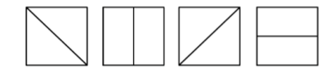
Colour in ½ of these shapes:

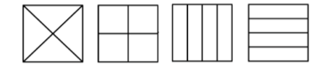
Colour in ¼ of these shapes:

Use the symbols < > and = to finish these statements:

½ is than ¼

¼ is than ½

¼ + ¼ to ½

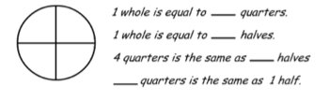
½ - ¼ to ½

