Extended Writing Homework
Look at the picture carefully and answer the questions in full sentences.
Don’t forget to use conjunctions, adjectives, capital letters and full stops.
For example: The seagull is telling the young girl “ follow me I have a surprise for you “
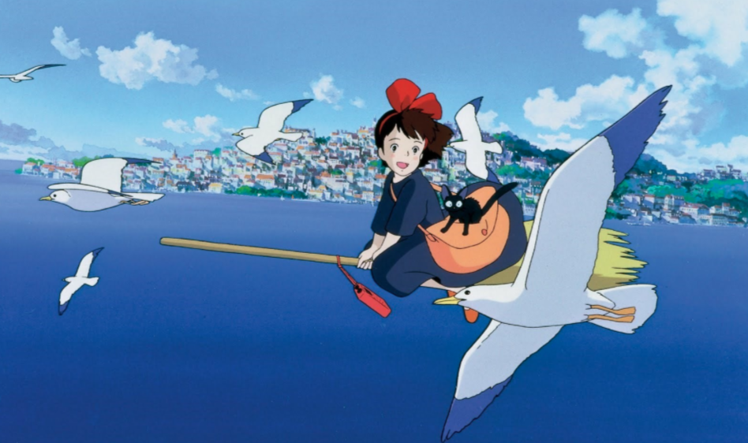

The girl is a witch called Kiki. Where is she going and why ?

Where does Kiki live ?

What is the seagull telling her ?

Describe what you can see. Don’t forget to use adjectives.

