Extended Writing Homework
Look at the picture carefully and answer the questions in full sentences.
Don’t forget to use conjunctions, adjectives, capital letters and full stops.
For example: The tired man feels cold from the harsh wind but he feel content because he has his faithful companion with him.
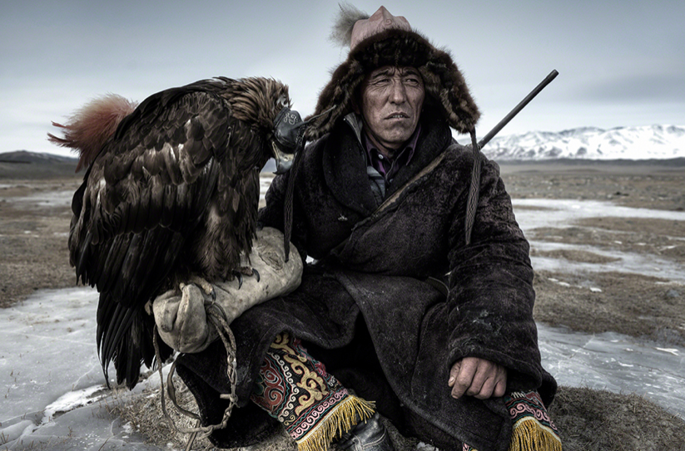

What is this man’s job?

What is the weather and how do you know?

What will the eagle and man do?

Describe what you can see. Don’t forget to use adjectives.

